The Elements- "Shape"

By [Matt Fussell](https://plus.google.com/u/0/116258551013095930484/)

FacebookTwitterGoogle+Pinterest

A shape is created when a line is enclosed.  Shape is one of the seven elements of art and it has a variety of uses in the creation of art.

[DOWNLOAD VIDEO](http://thevirtualinstructor.com/members/the-elements-of-art-shape-video-download-page/)

[](http://thevirtualinstructor.com/members)

THE USES OF SHAPE

We typically think of a shape as a closed contour.  So, if you take a line and enclose it, then you will have created a shape. Shapes can play important roles in the creation of art.  They help to create complex drawings and paintings, [affect composition](http://thevirtualinstructor.com/blog/5-tips-for-better-compositions), and contribute to the balance within a work.

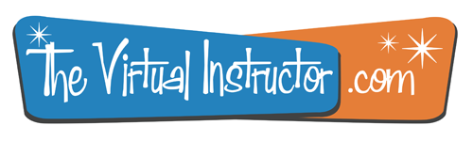

Get access to *ALL* of our courses today  
*...for just $1.*

[Learn More](http://thevirtualinstructor.com/members)

Shape is a two-dimensional area that is defined by a change in value or some other form of contrast.

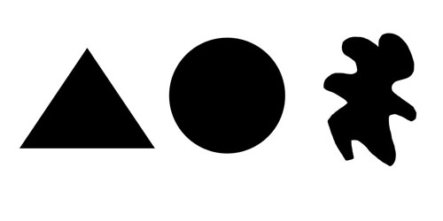

All shapes are two-dimensional, meaning that they have only length and width.

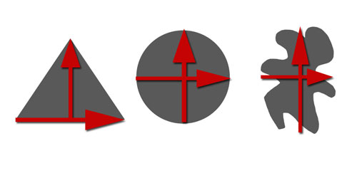

All shapes will fall into one of two categories. Geometric shapes or regular shapes are easy to recognize. Math can be used to find information about these shapes and these shapes generally have a specific name associated with them. Examples include: circle, triangle, square, and trapezoid.

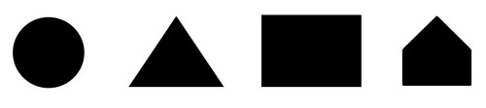

Organic or freeform shapes are shapes that seem to follow no rules. Organic shapes generally do not have a name associated with them and are typically not man-made.

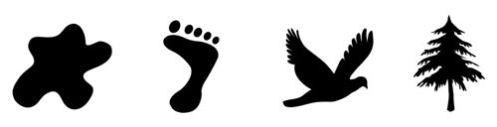

We can learn to see the world around us as shapes. Recognizing the shapes that we see will lead to improved drawing and painting.

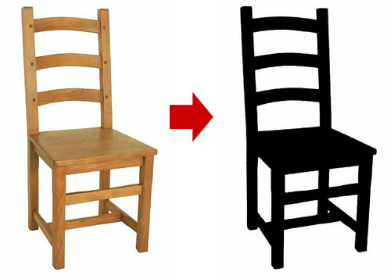

Shapes defined by objects are positive shapes (space). Shapes defined around objects are negative shapes (space).

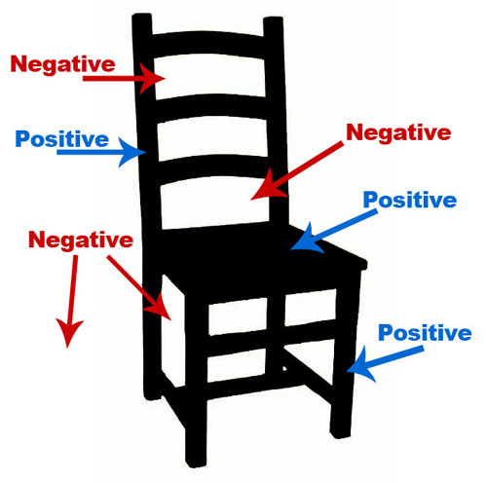

The relationships between the positive and negative shapes help the brain of our viewers understand what they are seeing.  Our brains are even capable of making sense of complex relationships between positive and negative shapes.

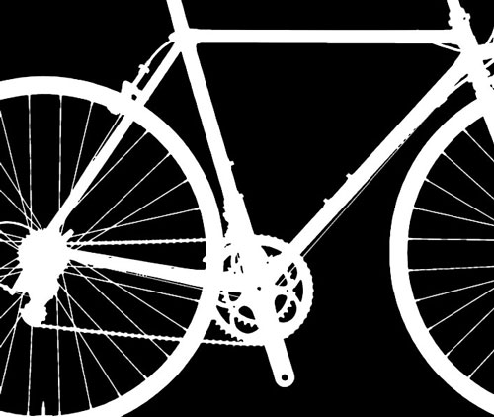

By organizing geometric and organic shapes, we can draw anything.  Even complicated objects become easy to draw when we isolate basic geometric and organic shapes.

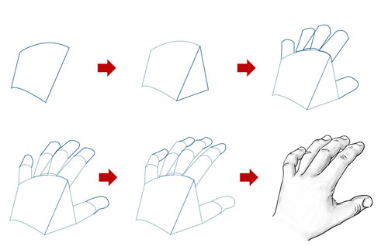

Terms  
*Shape -*an element of art that is a two-dimensional area that is defined in some way.  A shape may have an outline around it or you may recognize it by its area.

*Geometric shapes -* precise shapes that can be described using mathematical formulas.  Ex. Circle, square, triangle, oval, rectangle, parallelogram, trapezoid, pentagon, pentagram, hexagon, and octagon.

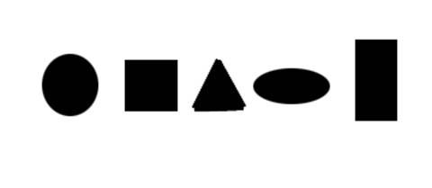

*Freeform Shapes -*also called organic shapes, are irregular and uneven shapes.  Their outlines may be curved, angular, or a combination of both

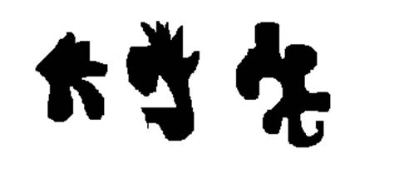

*Form -*an element of art, means objects that have three dimensions.  I like to think of form as a 3-D shape

*Form*and *Shape*are related.  You can turn a shape into the illusion of form by adding value and you can simplify a form from life into a shape.