# **The Elements of Art - "Line"**

By [Matt Fussell](https://plus.google.com/u/0/116258551013095930484/)

FacebookTwitterGoogle+Pinteres

Line is one of the seven [elements of art](http://thevirtualinstructor.com/artfundamentals.html).  It is considered by most to be the most basic element of art.

## 

## **THE USES OF LINE**

In terms of art, line is considered to be a moving dot.  It has an endless number of uses in the creation of art.

Line can control an viewer's eye.  It can describe edges.  It can indicate form as well as movement.  It can also indicate value and a light source in drawing.

When line is used for value or shading, we most typically see it used in the form of [hatching or cross hatching](http://thevirtualinstructor.com/hatchingcrosshatching.html). Although these are arguably the most common forms of using line for adding value, there is an endless number of ways that it can be used.

A simple way of thinking of a line is to imagine a point that moves...

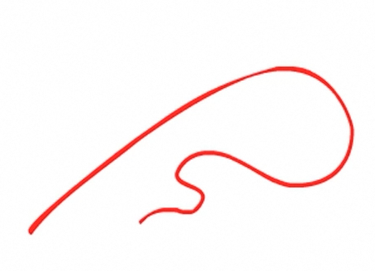

The most common use of line is showing where an object ends.  This type of line is called a [contour line](http://thevirtualinstructor.com/crosscontour.html).  Contour lines are most commonly called outlines.

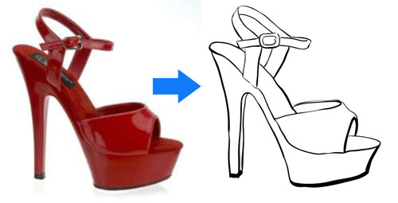

Line can also create the illusion of form in a drawing. [Line quality](http://thevirtualinstructor.com/line-quality-cross-contour.html) is the thickness or thinness of a line.  By varying the line quality an artist can show form in a drawing with just the use of line.

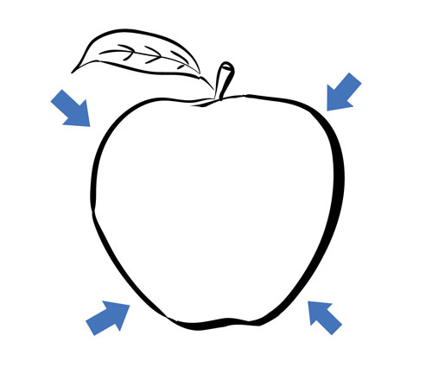

Line can also indicate shadow and form through the use of [cross contour lines](http://thevirtualinstructor.com/line-quality-cross-contour.html).  Cross contour lines follow the contours of the object.  Much like running your finger around the form of an object.

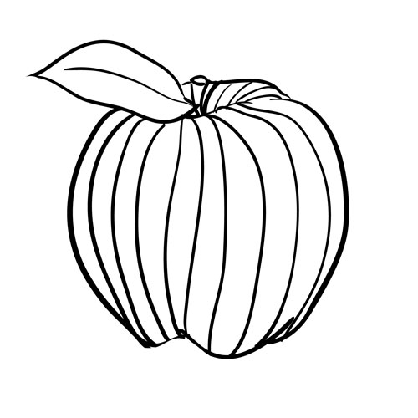

Line- element of art.  In terms of art, line can be described as a moving dot.  Line is perhaps the most basic element of drawing.

## **TYPES OF LINES**

Vertical lines - lines that move up and down without any slant  
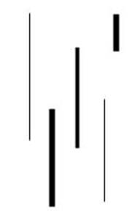  
Horizontal lines - lines that are parallel to the horizon  
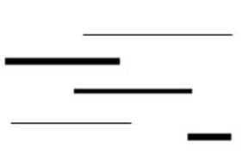  
Diagonal lines - lines that slant  
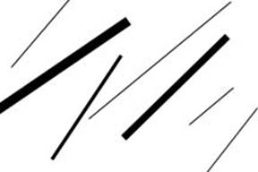  
Zigzag lines - lines made from a combination of diagonal lines  
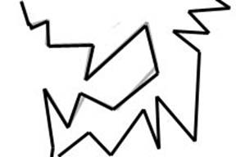  
  
Curved lines - Lines that change direction gradually  
            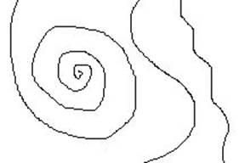

Line Variation - adding interest to your lines is important in creating successful artwork

Length - lines can be long or short

*he Elements of Art- Line*

Width - lines can be wide or skinny

*he Elements of Art-line*

Texture - lines can be rough or smooth

*he Elements of Art- Line*

Direction - lines can move in any direction

Degree of curve - lines can curve gradually or not at all

Line quality or line weight - refers to the thickness or thinness of a line.  By varying the line quality artists can make objects appear more 3-Deminsional and more interesting

Hatching and crosshatching - using lines to create value

Hatching - lines going in the same direction  
Crosshatching - lines that cross